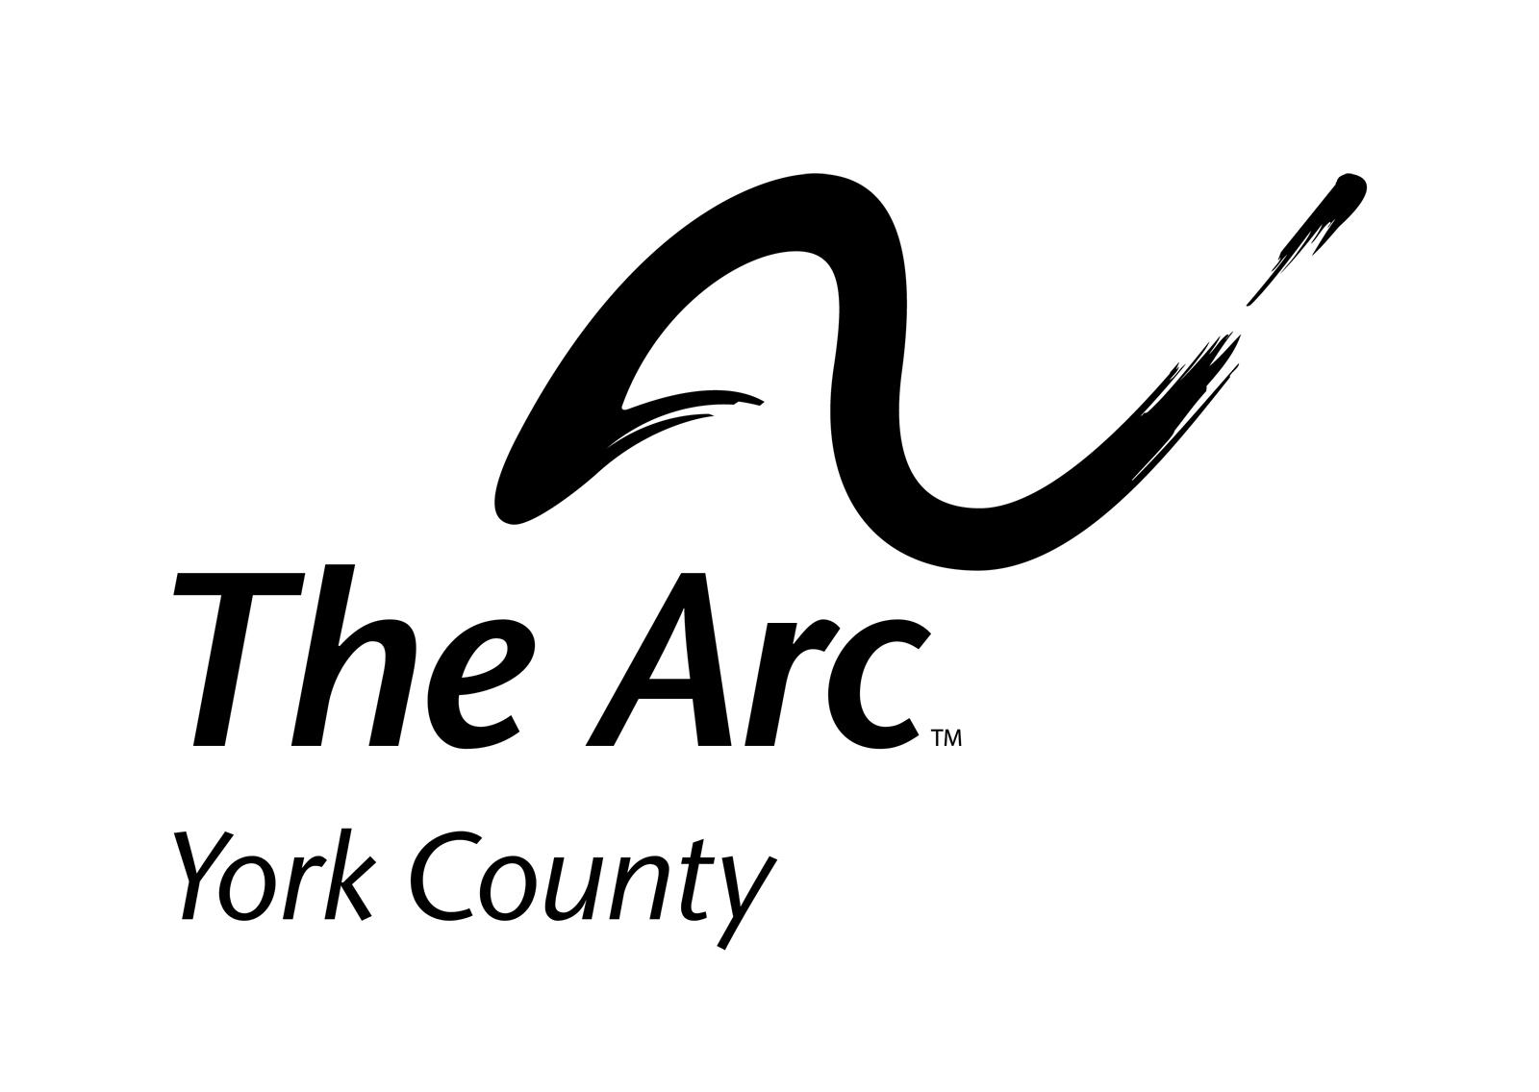
AFTER SCHOOL PROGRAM
at RLASHS
2022-2023

APPLICATION / EMERGENCY INFORMATION FORM

Student’s Name _________________________________________ Age ______________
Address ____________________________________________________________________
Street City State Zip

Date of Birth _________________ School Building Attending __________________________
Class in School _____________________________ Teacher _________________________
MH/IDD Case Manager _____________________________Phone #____________________

Mother’s (Guardian’s) Name __________________________ Phone # ________________
Address ____________________________________________________________________
Street City State Zip
Place of Employment __________________________________ Phone # _______________
Work Address _______________________________________________________________
Street City State Zip
Work Hours _________________________________ Email address ___________________

Father’s Name _____________________________________ Phone # _________________
Address _____________________________________________________________________
Street City State Zip
Place of Employment _______________________________ Phone # __________________
Work Address________________________________________________________________
Street City State Zip
Work Hours _________________________________ Email address ___________________

Person to contact in an emergency: If parents cannot be reached, who is familiar with member and is available from 2:45 PM - 6:00 PM.?
Name ___________________________________________ Phone # __________________
Address _____________________________________________________________________
Street City State Zip

Student’s Physician
Name ___________________________________________ Phone # __________________
Address_____________________________________________________________________
Street City State Zip
Hospital _____________________________________

Please complete this form and return it to: The Arc of York County
497 Hill Street
York, PA 17403
Revised 7/16/19 This information will be kept strictly confidential. Thank you.

Health Insurance or PA Medical Assistance (ACCESS)
Name of Company ____________________________ Recipient Name _________________
Policy # _________________________________
Group # _________________________________
Individual Number # ________________________

STUDENT’S DIAGNOSIS:___________________________________________________

SPECIAL DISABILITY INSTRUCTIONS (please be specific)

Special disability, medical or dietary information necessary for management in an emergency - allergies, medications, seizures, _________________________________________________
___________________________________________________________________________
___________________________________________________________________________

Medication(s)

Please list any medications the member takes on a regular basis.

Name of medication |  | Dosage |  | Time

While attending the After-School Program, I give permission to staff to use their own judgment in administering the following if needed:
_______ Tylenol ____________________________________________ (indicate amount)
_______ Advil (Ibuprofen) ______________________________________ (indicate amount)
_______ Triple Antibiotic Ointment

Please list all persons to whom student may be released. Students will NOT be released to anyone else without notification from parent (s) / guardian and proof of identity upon picking up student.
___________________________ _____________________________
___________________________ _____________________________
___________________________ _____________________________

If emergency treatment is required, I give my consent for the After-School Options Program staff to send ________________________________________ to the hospital most quickly accessible and I will be responsible for any medical fees incurred by such an emergency

________________________________________ _____________________
Parent/Guardian Signature Date

HEALTH EXAMINATION BY LICENSED PHYSICIAN

Student’s Name _______________________________________ Date: ________________

I _________________________________ authorize my Physician to provide the following
Parent/Guardian
Information.
I understand that it will be used only by The Arc of York County’s staff to care for my child.

Signature ____________________________________________ Date __________________

All information is to be completed by a licensed physician.

I have examined the above person within the past year.
Date of Exam: _________________

Is the person free of infectious diseases? Yes_________ No______________
If no, please indicate type of disease ______________________________________________________

Medication(s) prescribed and dosage(s):

Medication Dosage
_____________________ ____________________
_____________________ ____________________
_____________________ ____________________
_____________________ ____________________
_____________________ ____________________

Medical information pertinent to diagnosis and treatment in case of an emergency: _________________________________________________________________________________________________________________________________________________________________________________________________________________________________

Recommended modifications or limitations of applicant’s activities or diet:
___________________________________________________________________________
___________________________________________________________________________

Is there any medical reason that this person should not participate in an after school activity which may include swimming, basketball, exercise machines, weight lifting, games, crafts, and computers?
_____________ YES ____________ NO

If yes, please elaborate. ______________________________________________________________________________________________________________________________________________________
___________________________________________________________________________

IMMUNIZATIONS

Vaccines | Dates given
DTP: Diphtheria-Tetanus-Pertussis | 1. 4.  2. 5.  3. 6.
TOPV Trivalent Oral Polio | 1. 4.  2. 5.  3.
Measles | 1.  2.
Mumps | 1.  2.
Rubella | 1.  2.
HIB Haemophilus | 1.  2.
Hep B Hepatitis B | 1.  2.
Tuberculin test

Form completed by ___________________________________________________________
For/ by Dr. ___________________________________________________________________
Please type or print

Licensed Physician’s Signature ___________________________________________________________
Telephone: ___________________________
Address: ___________________________________________________________________________
Street City State Zip

Date form completed ___________________________

AGREEMENT

This agreement is between The Arc of York County and the parents of ____________________________ in order for him/her to attend the After-School Options Program. This agreement remains in effect as long as he/she is enrolled in the program.

The After-School Options Program agrees to:

- Provide day care services from 2:45 PM - 6:00 PM, Monday through Friday, on days that schools are in session.
- Provide a safe and appropriate physical site and program.
- Provide supervision of students enrolled.
- Hire qualified staff that have proper criminal and child abuse clearances.
- Keep all records confidential and release information to other parties only upon written consent of the parent(s) in accordance with HIPAA.
- Keep emergency information on hand at all times; provide emergency medical care when needed; in case of an emergency, notify parent or emergency contact person as soon as possible; and accompany student to the emergency center and remain with the student until the parent(s) or designee assumes responsibility.
- Provide a variety of activities – fun, learning.
- Provide snacks and rest as student needs.
- Release the student only to those persons designated in writing by the parent(s)/guardian(s).
- Provide after school services starting at an earlier time for regularly scheduled early dismissals from school when staffing allows.
- Weather related emergency dismissals- The After-School Options Program agrees with Red Lion Area School District's decision that students are to go home when school dismisses early for these emergencies.

The parent(s)/guardian(s) agree to:

- Supply all information and records as required for the program.
- Pick up the member or arrange for transportation home by 6:00 PM. Parents will be billed $5.00 for every 15 minutes they are tardy, beginning at 6:15 pm. This money will come from their personal finances, not YAC MH/IDD.
- Notify the After-School Options Program of any changes in address, telephone number, or emergency information.
- Notify the After-School Options Program if the member will not be attending on a particular day.
- Notify the After-School Options Program of any early dismissals (holiday schedules, in-service days, etc.) other than weather related emergencies so we can arrange for staff to be available.
- Keep the member home if they are too sick to be around the other students.
- MAKE ARRANGEMENTS FOR THE MEMBER TO GO HOME WHEN THE SCHOOL DISTRICT ANNOUNCES EARLY DISMISSAL DUE TO WEATHER OR OTHER EMERGENCIES.

________________________________________ __________________________________________
(Signature of After School Options Coordinator) Date (Signature of Parent(s)/Guardian(s) Date

LIABILITY RELEASE

We, the parents/guardians of

__________________________________________________________________________
(Print Name)
Hereby give permission to have our child actively participate in the various activities that will be a part of the After-School Options Program, sponsored by The Arc of York County. These activities may occur at either the Red Lion Area Senior High School, or other community business. The activities include but are not limited to - arts and crafts; games; music; dancing; sports.

Absent gross negligence or wrong doing by The Arc of York County, Inc., (or its affiliates) or its staff, we hereby release The Arc of York County; Red Lion Area School District, the After School Options Program, staff, volunteers, and any and all other persons who assist in taking charge of the said programs and activities from any and all liability or claim rising from the accidental injury to, or death of, our child incurred during or in transit to or from our child’s participation in programs and activities from any cause whatsoever.

We further waive claim on The Arc of York County, and Red Lion Area School District for any loss or damage to my child’s property, whether at the school, or en-route to and from the site.

Intending to be legally bound hereby, we set our signatures below.

_________________________________________________________________________
(Signature of Parent/Guardian) (Date

_________________________________________________________________________
(Signature of Parent/Guardian) (Date)

RELEASE OF INFORMATION

I / We, ______________________________________________________________________
(Name of parent / guardian)
Authorize
_________________________________________ , _________________________________________ ,
(Name of the School Your Child Attends)
And ___________________________________________________ as well as York County
(List any other support agencies you feel we may need to contact, such as wrap-around agencies.)
MH-IDD, to release information to The Arc of York County in order to optimize care on behalf of _____________________________________________________.
(Name of Student)

This information may include copies of assessment documents including psychological evaluations, treatment plans, medical reports, current Individual Education Plans, and teacher interviews. This information will remain confidential.

_____________________________________________________ ___________________
(Signature of Parent/Guardian) (Date)

TRANSPORTATION RELEASE
**needed for students who do not attend RLASHS

__________________________________________ will be attending The Arc of York County’s
(Name of Student)

After School Options Program beginning on the following date __________________________
(First Day of Transportation)

Red Lion Area School District, or its sub-contractors, has my permission to transport my child to Red Lion Area Senior High School at 200 Horace Mann Ave., Red Lion, PA 17356, on a daily basis after school.

__________________________________________________________________________
(Signature of Parent or Guardian) (Date)

Note: Parents need to make arrangements with Rabbittransit if your child will be using Rabbittransit vans to go home from the After-School Options Program.

PHOTOGRAPHY RELEASE

I give my permission for photographs of my child at the After School Options Program to be published in the local newspapers or other media or in the newsletter of The Arc of York County.

___________________________________________________________________________
(Signature of Parent/Guardian) (Date)

THE ARC OF YORK COUNTY HOUSEHOLD SURVEY

The Arc of York County receives contributions and funding from many sources, including United Way and the County of York. They have requested that we collect the following information. It is not mandatory for you to complete this form, but it will be appreciated as it will help The Arc receive much needed funding.
1. Please check the gender of the person(s) who will receive Arc services.
_____ Female _____ Male

2. Please check the age range of the person(s) who will receive Arc services.
0-5 _____ 6-8 _____ 9-14 _____ 15-18 _____ 19-21 _____ 22-61 _____ 62+ _____

3. Is the person who receives Arc services Hispanic/Latino?
_____ Yes _____ No

4. Please check which one racial description best fits the person who receives Arc Services: (Check one only)

Single Race |  | OR | Multi-Race
White |  |  | Black or African American AND White
Black or African American |  |  | Asian AND White
Asian |  |  | American Indian or Alaska Native AND White
American Indian or Alaska Native |  |  | American Indian or Alaska Native AND  Black or African American
Native Hawaiian or Another Pacific Islander |  |  | Another Multi-Race

5. Please indicate the total number of persons currently residing in your household. ___________

6. Please check which of the following describes your family’s “head of household.” (Check only one.)
__________ Male __________ Female __________ Two Parents

7. What is your total yearly family income from wages or salary, self-employment, social security?
Pension, public, assistance, rent, interest, or other sources? (Check one line only.)

_____ $ 0---11,250
_____ $11,251---12,850
_____ $12,851---14,450
_____ $14,451---16,100
_____ $16,101---17,350
_____ $17,351---18,650
_____ $18,651---18,750
_____ $18,751---19,950
_____ $19,951---21,250
_____ $21,251---21,450
_____ $21,451---24,100
_____ $24,101---26,800
_____ $26,801---28,950
_____ $28,951---30,000
_____ $30,001---31,100
_____ $31,101---33,250
_____ $33,251---34,300
_____ $34,301---35,400
_____ $35,401---38,600
_____ $38,601---42,900
_____ $42,901---46,300
_____ $46,301---49,750
_____ $49,751---53,150
_____ $53,151---56,600
_____ 56,601 & over
_____ Unknown

8. Please list the places of employment for all members of your household. ______________________________________________________________________________________________________________________________________________________________________

9. Name of Individual Receiving Services _____________________________________________
Address ______________________________________________________________________

Signature of Person completing Form ______________________________________________

The Arc of York County

Medical Needs Survey

Please feel free to offer any additional comments to the questions in this survey.
Participation in this survey is optional. It can be completed anonymously if preferred. By completing this form, you will be assisting The Arc of
York County staff to advocate for people with disabilities with regard to medical services including both general practice and specialties.

1. When seeking medical treatment/services is it important to you that the provider has
experience treating people with intellectual/developmental disabilities.

2. Have you had difficulty in the past finding doctors who are comfortable serving individuals
with intellectual and other disabilities.

3. If The Arc identified medical service providers who are experienced with and recommended
for people with intellectual and other disabilities, would that information be useful to you?

4. Are you currently satisfied that your medical provider has a thorough understanding of
your family member’s disability and how to serve them?

5. Would it be important for you to have cooperating providers in one location?

Signature (optional)__________________________________________________

Printed Name (optional)_____________________________________________

